**ECEN 325 - Lab Report**

**Lab Number: 3**

**Lab Title: Operational Amplifiers- Part 1**

**Section Number: 503**

**Student’s Name:** [Alex Allahar](mailto:alex.allahar@tamu.edu)

**Student’s UIN: 928009686**

**Date: 09/24/23**

**TA: Ángel Ocasio-Rodriguez**

1. **Tabulate all of the Opamp parameters measured in the lab. Look up the same parameters on the datasheet for the 741 Opamp. Calculate and list the differences between your measurement and the specified values given by the manufacturer.**

| UA741 OpAmp Parameters | Manufacturer | Measurement |
| --- | --- | --- |
| Supply Voltage | +/- 5 V | +/- 5 V |
| Input Offset Voltage | 1 mV | 0.068 mV |
| Voltage Gain | 200 V/mV | 200 V/mV |
| Power Consumption | 50 mW | 50 mW |
| Output Resistance | 75 Ω | 75 Ω |
| Bandwidth | 1.2 MHz | 1.2 Mhz |
| Input Resistance | 2 MΩ | 2 MΩ |
| Input Offset Current | 20 nA | 21.3 nA |
| Slew Rate | 0.5 V/us | 0.5 V/us |

The differences between the manufacture data sheet and the measurement parameters were: Input Offset Current and Input Offset Voltage.

1. **Measurement Plots**
2. **Inverting Bode Plot**

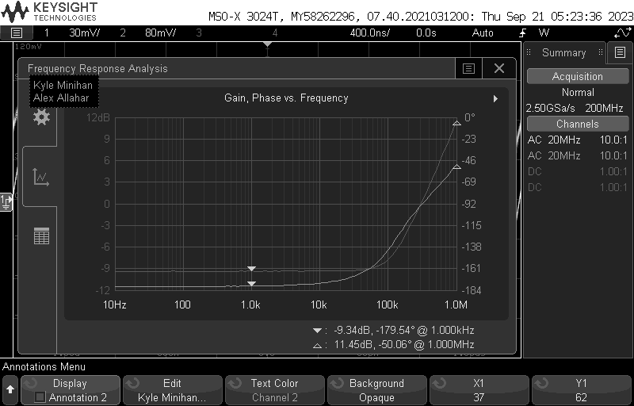

1. **Inverting Transient Plot**

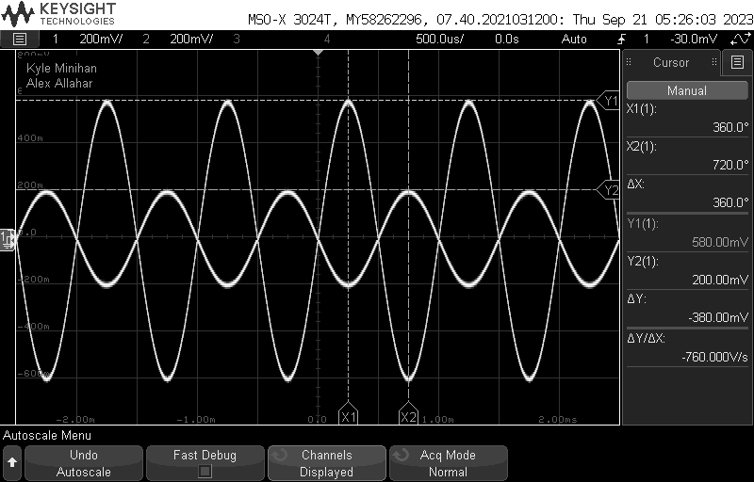

1. **Inverting Parameter Sweep Plot**

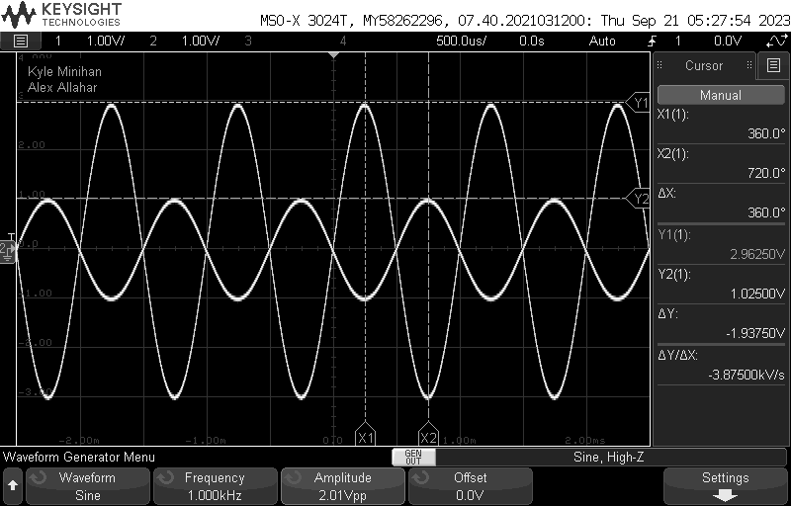

1. **Inverting THD Plot**

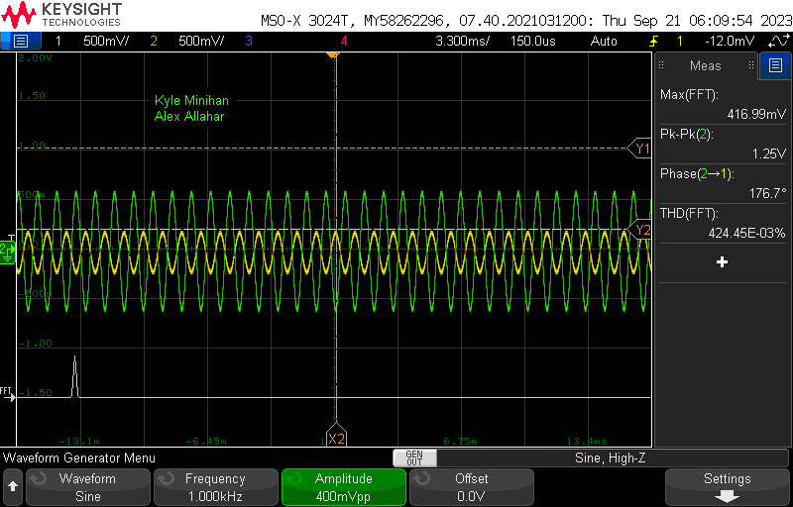

1. **Non-Inverting Bode Plot**

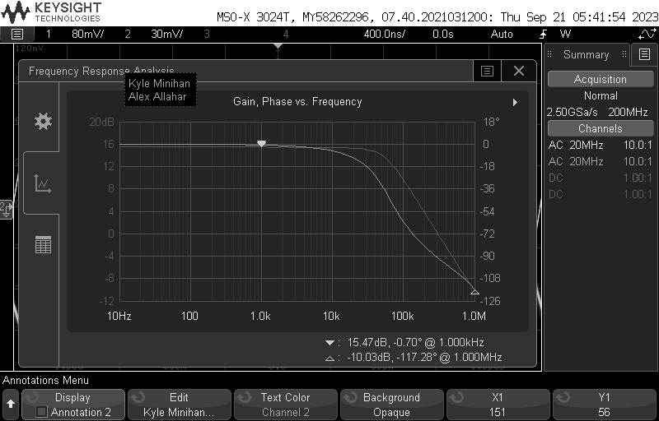

1. **Non-Inverting Transient Plot**

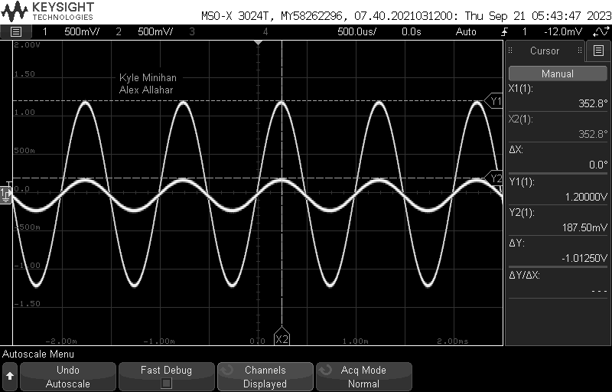

1. **Non-Inverting Parameter Sweep Plot**

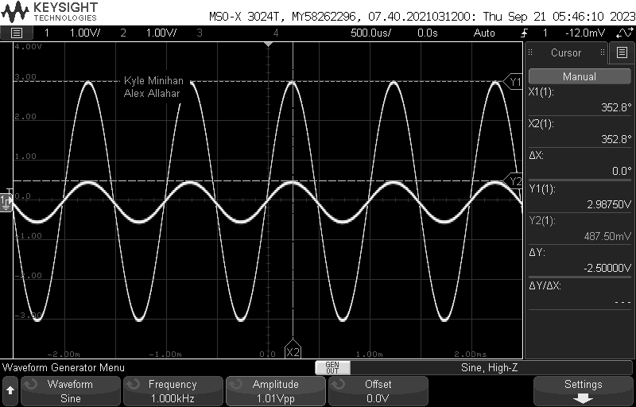

1. **Non-Inverting THD Plot**

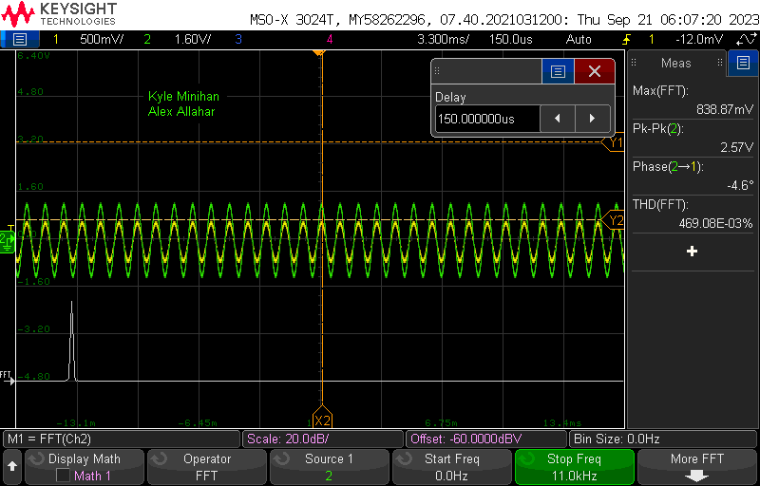

**3. Table**

| Parameter | Calculated | Simulated | Measured |
| --- | --- | --- | --- |
| R2 | 30 kΩ | 30 kΩ | 30 kΩ |
| R4 | 50 kΩ | 50 kΩ | 50 kΩ |
| Inverting Magnitude @ 1kHz | N/A | 9.551 dB | -9.34 dB |
| Inverting Phase @ 1kHz | N/A | 179.9 ° | -179.54 ° |
| Inverting Vin | N/A | 0.2 V | 0.2 V |
| Inverting Vout | N/A | 0.598 V | 0.580 V |
| Inverting Vmax | N/A | 0.81 V | 1.02 V |
| Inverting THD | N/A | N/A | 0.424 % |
| Non-Inverting Magnitude @ 1kHz | N/A | 6.101 dB | 15.47 dB |
| Non-Inverting Phase @ 1 kHz | N/A | -.37 ° | -0.7 ° |
| Non-Inverting Vin | N/A | 0.2 V | 0.187 V |
| Non-Inverting Vout | N/A | 1.21 V | 1.2 V |
| Non-Inverting Vmax | N/A | 0.49 V | .487 V |
| Non-Inverting THD | N/A | N/A | 0.469 % |

**4. Compare the results and comment on differences**

The inverting, non-inverting, and voltage follower circuits behaved as expected during the experiment. The inverting bode plot was flipped during the lab resulting in the magnitude and phase being negative. Since I used multisim online, I was unable to plot the THD. This resulted in me not having simulated values of the THD to compare to the measured values. Also, to obtain the simulated Vmax I increased the Vin by 0.1 V until clipping occurred. After comparing these values to the values measured they are not that far off. Both the Non-Inverting and Inverting experience clipping when the Vout got near 3V. The voltage follower did not experience clipping even near 5V.